Documentação/fontes que podem ser importantes para o projeto

(No fundo um protótipo para o relatório)

Fontes:

opencv-python-examples: <https://github.com/cfgnunes/opencv-python-examples> OpenCV Course - Full Tutorial with Python: <https://www.youtube.com/watch?v=oXlwWbU8l2o>

Fire Detection System in Python using Opencv: <https://www.youtube.com/watch?v=2uxfqlDbVV4>

YOLO object detection using Opencv with Python: <https://www.youtube.com/watch?v=h56M5iUVgGs>

REAL TIME OBJECT MEASUREMENT | OpenCV Python (2020): <https://www.youtube.com/watch?v=tk9war7_y0Q>

Detecting California Fires using Python (Smoke Detection): <https://www.youtube.com/watch?v=__fk2BVsDIs>

Gesture Volume Control | OpenCV Python 2021: <https://www.youtube.com/watch?v=9iEPzbG-xLE>

S. Shalev-Shwartz and S. Ben-David, Understanding machine learning. Cambridge: Cambridge University Press, 2019. "OpenCV: OpenCV modules", Docs.opencv.org, 2021. [Online]. Disponível em: <https://docs.opencv.org/master/>

"Welcome to the OpenCV tutorial — OpenCV tutorial 2019 documentation", Opencv-tutorial.readthedocs.io, 2021. [Online]. Disponível em: <https://opencv-tutorial.readthedocs.io/en/latest/index.html>..

K. Murphy, Machine learning. Cambridge, Mass.: MIT Press, 2013.

<https://docs.microsoft.com/pt-pt/azure/api-management/import-and-publish>

<https://kivy.org/#home>

<https://www.youtube.com/watch?v=TKcDksx1y9E>

<https://cloudxlab.com/blog/how-to-run-yolo-on-cctv-feed/>

<https://realpython.com/flask-connexion-rest-api/>

<https://stackoverflow.com/questions/60175027/best-way-to-deploy-python-flask-app-with-opencv-on-azure>

<https://medium.com/@nikovrdoljak/deploy-your-flask-app-on-azure-in-3-easy-steps-b2fe388a589e>

<https://www.youtube.com/watch?v=Z1RJmh_OqeA>

<https://www.reddit.com/r/flask/comments/2urjjy/flask_app_as_standalone_offline_application/>

<https://www.youtube.com/watch?v=zJDUhGL26iU>

<https://www.youtube.com/watch?v=saDipJR14Lc>

<https://pjreddie.com/darknet/yolo/>

<https://medium.com/analytics-vidhya/object-detection-using-yolo-v3-and-deploying-it-on-docker-and-minikube-c1192e81ae7a>

<https://www.youtube.com/watch?v=GGeF_3QOHGE&t=491s>

<https://blog.insightdatascience.com/how-to-train-your-own-yolov3-detector-from-scratch-224d10e55de2>

<https://github.com/darshanadakane/yolov3_realTimeObjectDetection/blob/master/YOLO_ObjectDetectionInVideo_git.ipynb>

<https://github.com/spmallick/learnopencv/tree/master/ObjectDetection-YOLO>

<https://www.pyimagesearch.com/2020/02/03/how-to-use-opencvs-dnn-module-with-nvidia-gpus-cuda-and-cudnn/>

<https://docs.microsoft.com/pt-pt/azure/virtual-machines/linux/quick-create-portal>

<https://www.youtube.com/watch?v=_4A9inxGqRM>

<https://blog.francium.tech/custom-object-training-and-detection-with-yolov3-darknet-and-opencv-41542f2ff44e>

<https://github.com/AlexeyAB/darknet> - Windows(baseada na oficial mas também dá Linux)

<https://www.digitalocean.com/community/tutorials/how-to-serve-flask-applications-with-uswgi-and-nginx-on-ubuntu-18-04-pt>

<https://github.com/pjreddie/darknet> - Linux(oficial, é fazer make e nuns os 3 ou 4 passos está instalado mas só com CPU, GPU requer mais passos)

<https://azureforeducation.microsoft.com/devtools>

<https://docs.nvidia.com/ngc/ngc-azure-setup-guide/launching-gpu-cloud-instance-from-azure-portal.html>

<https://www.youtube.com/watch?v=YsmhKar8oOc> -> Compilação e instalação de Cuda no Windows 10

<https://www.pyimagesearch.com/2020/02/03/how-to-use-opencvs-dnn-module-with-nvidia-gpus-cuda-and-cudnn/> -> Unix (MacOS e Linux) o assunto é o mesmo do link de cima

<https://www.youtube.com/watch?v=3vHvOyZ0GbY>

<https://github.com/theAIGuysCode/Object-Detection-API>

<https://www.pyimagesearch.com/2019/09/09/multiprocessing-with-opencv-and-python/>

<https://www.reddit.com/r/opencv/comments/ggp86e/bug_how_can_i_access_a_clients_webcam_in_a_flask/?utm_medium=android_app&utm_source=share>

<https://github.com/opencv/opencv-python/issues/198>

<https://github.com/akmamun/multiple-camera-stream>

<https://stackoverflow.com/questions/58931854/how-to-stream-live-video-frames-from-client-to-flask-server-and-back-to-the-clie>

<http://www.linfo.org/path_env_var.html>

<https://learnopencv.com/opencv-dnn-with-gpu-support/#prerequisites>

Tópicos para se falar no relatório/fazer:

- O resultado do código do ano passado caso a Leitek nos forneça; (provavelmente não é mais necessário após as experiências que fizemos)

- Temos de criar o Project para apresentar em breve;

- Fazer uma introdução de alguns conceitos que vamos utilizar;

- Falar da experiência inicial que o Bruno fez com o OpenCV, o código de streaming test que obteve um bom resultado;

- Cenas do Azure;

- A guerra pelo CUDA na máquina virtual criada no Azure (a pedido do Bruno);

Assuntos chaves para utilização de coisas:

O venv chama-se envidere;

ssh -i. \Downloads\myKey1.pem [azureuser@10.111.12.123](mailto:azureuser@10.111.12.123)

Ficheiro videre_key.pem;

<http://79.10.24.158/cgi-bin/faststream.jpg?stream=half&fps=15&rand=COUNTER>

<https://discord.com/channels/829383166673944617/829383167269273682/835867399809925130>

<http://www.insecam.org/>

<https://youtu.be/iIhAfX4iek0>

<https://www.youtube.com/watch?v=GMppyAPbLYk>

<https://www.geeksforgeeks.org/retrieving-html-from-data-using-flask/>

<https://cdn.discordapp.com/attachments/829383167269273682/834707646748557312/Projeto1.mpp>

<https://cdn.discordapp.com/attachments/829383167269273682/834453967370321920/Videre_key.pem>

Anexos dos resultados:

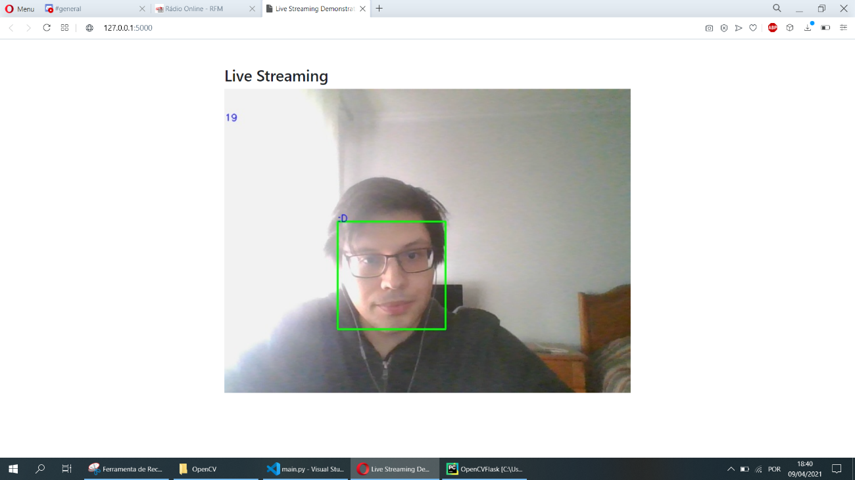

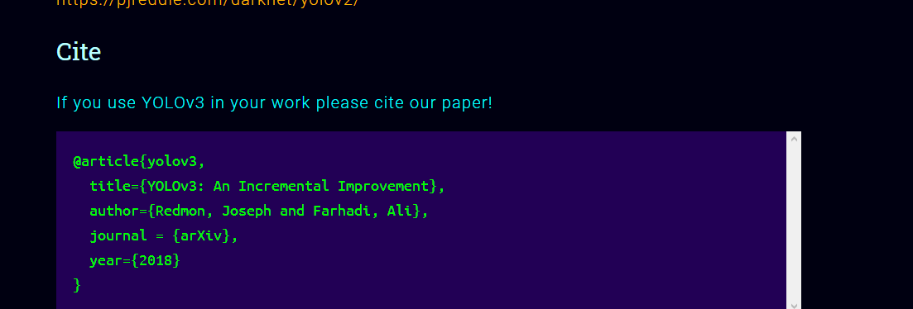

Source: <https://pjreddie.com/darknet/yolo/>

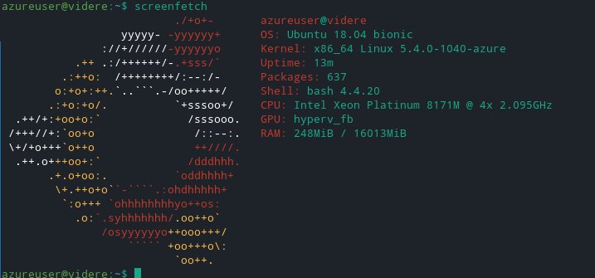

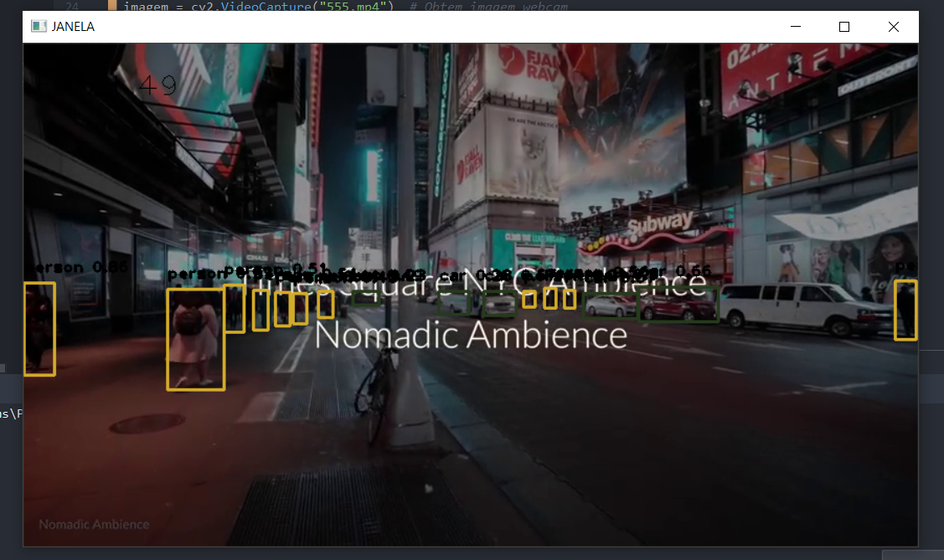

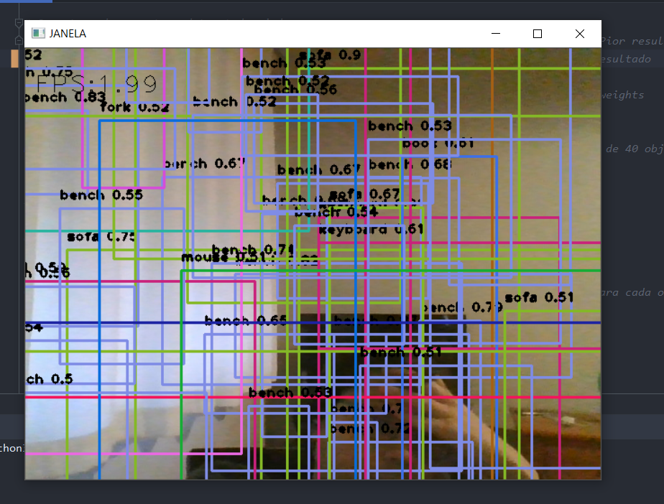

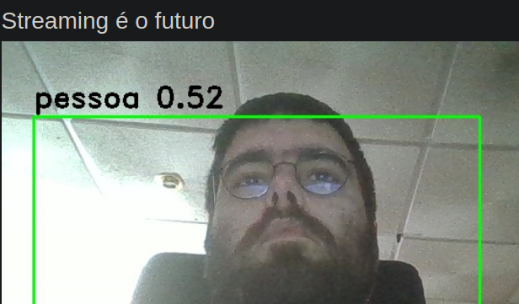

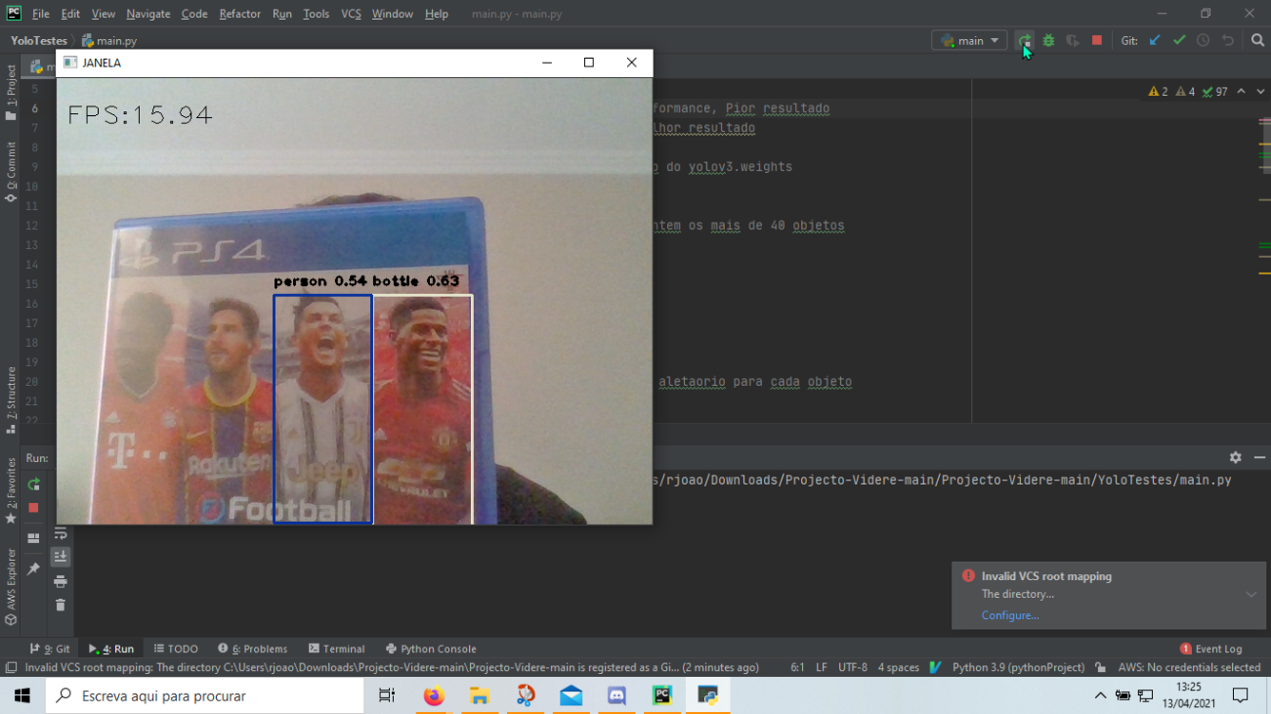

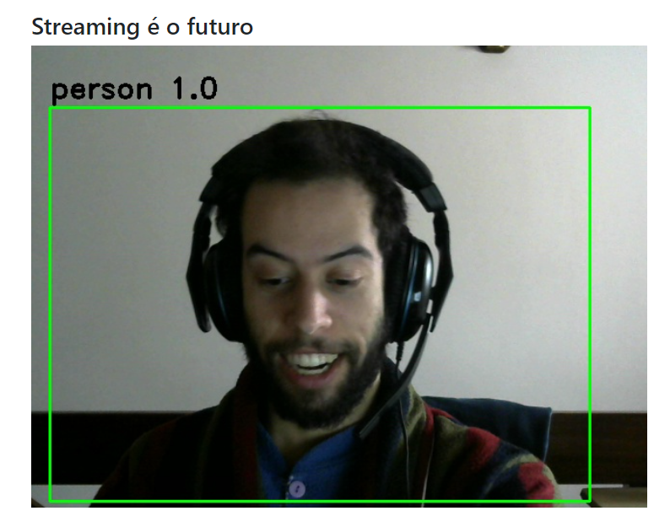

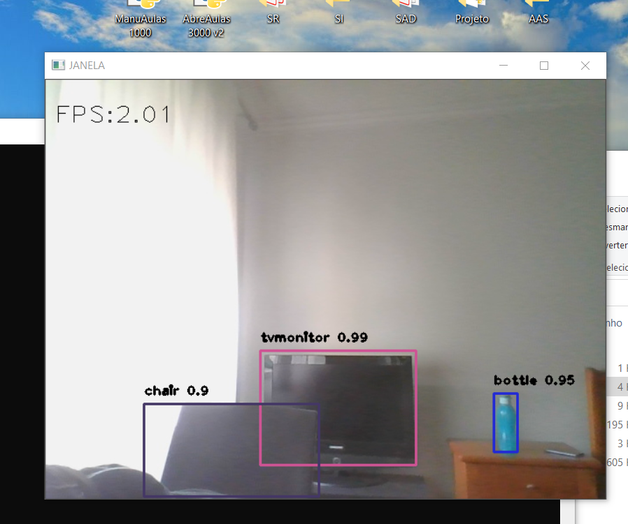

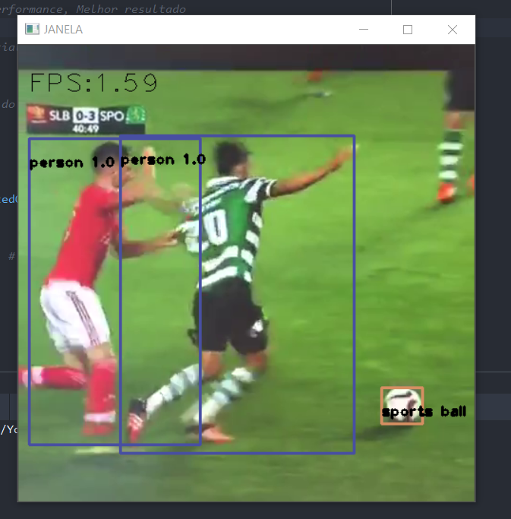

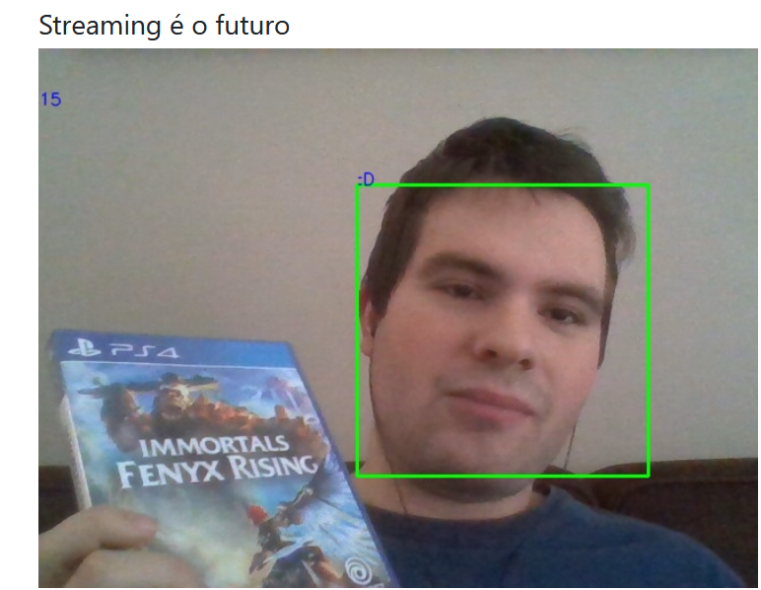

Múltipla sessão:

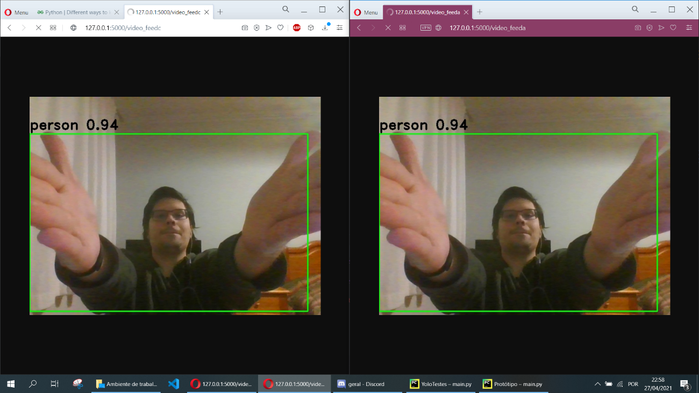

2 imagens pela mesma câmara:

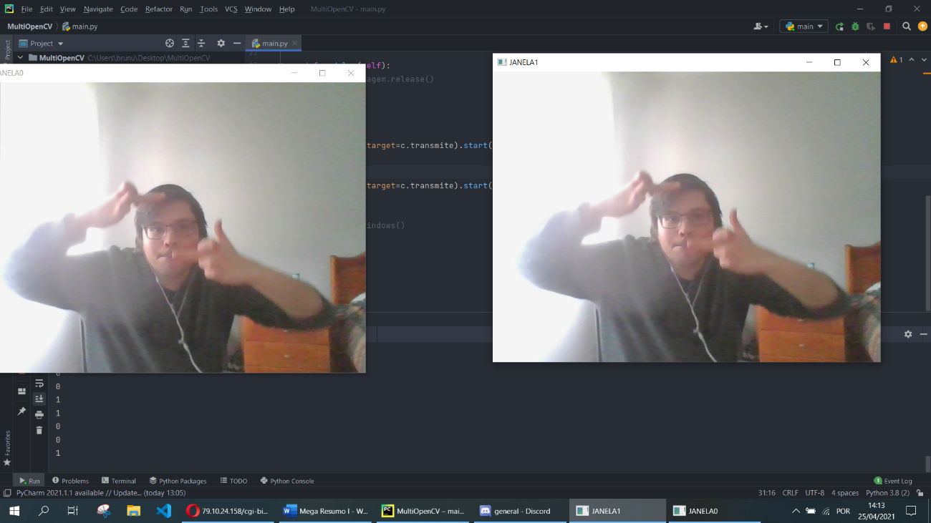

(Convém não ser esta imagem hahahaha)

Funcionamento de multithreading (múltiplas câmaras capturadas ao mesmo tempo):

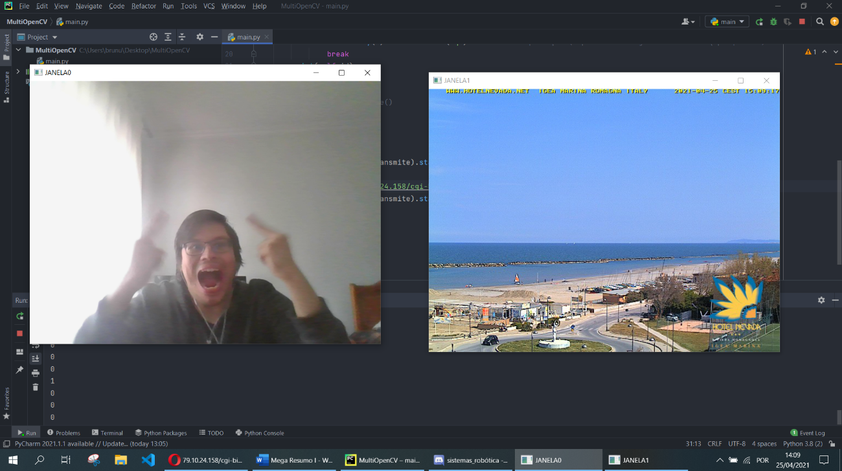

Experimentos para o website:

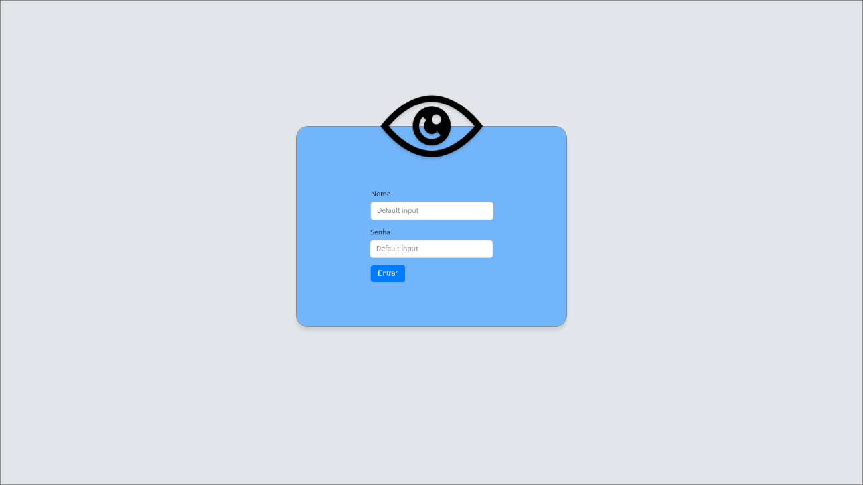

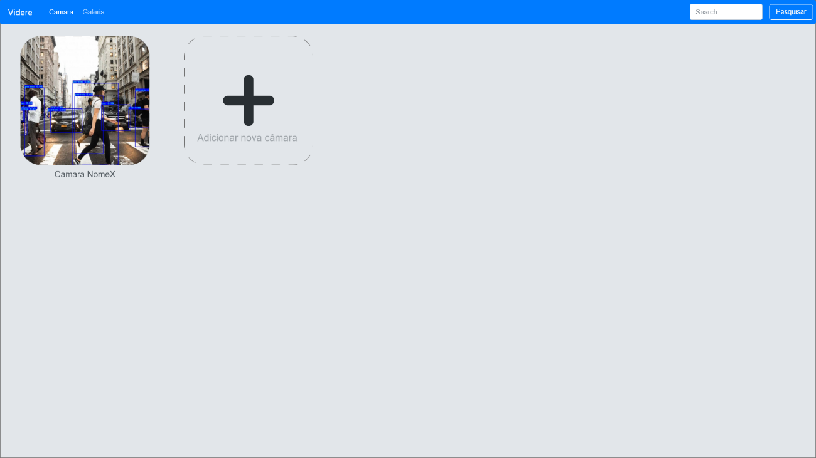

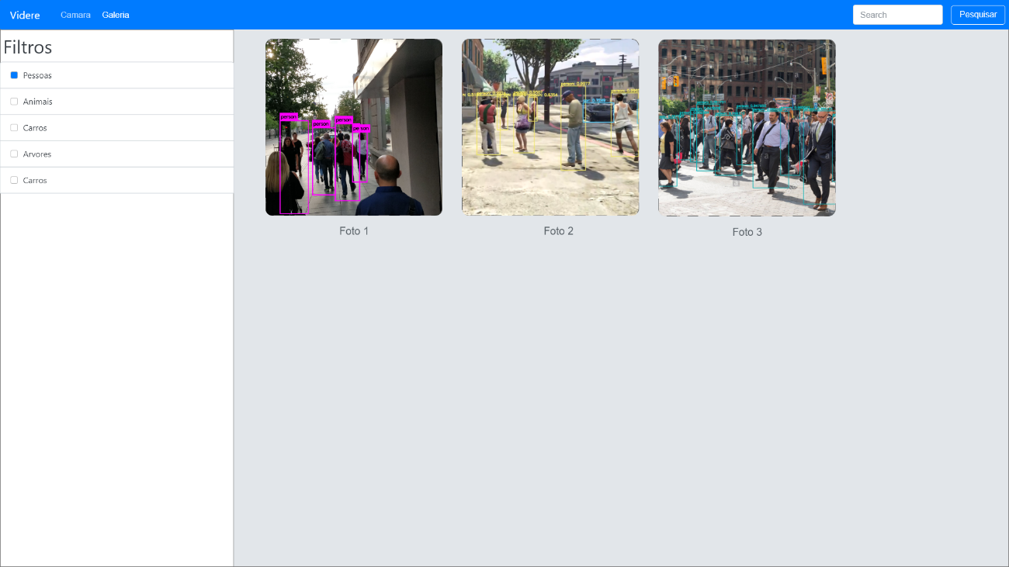

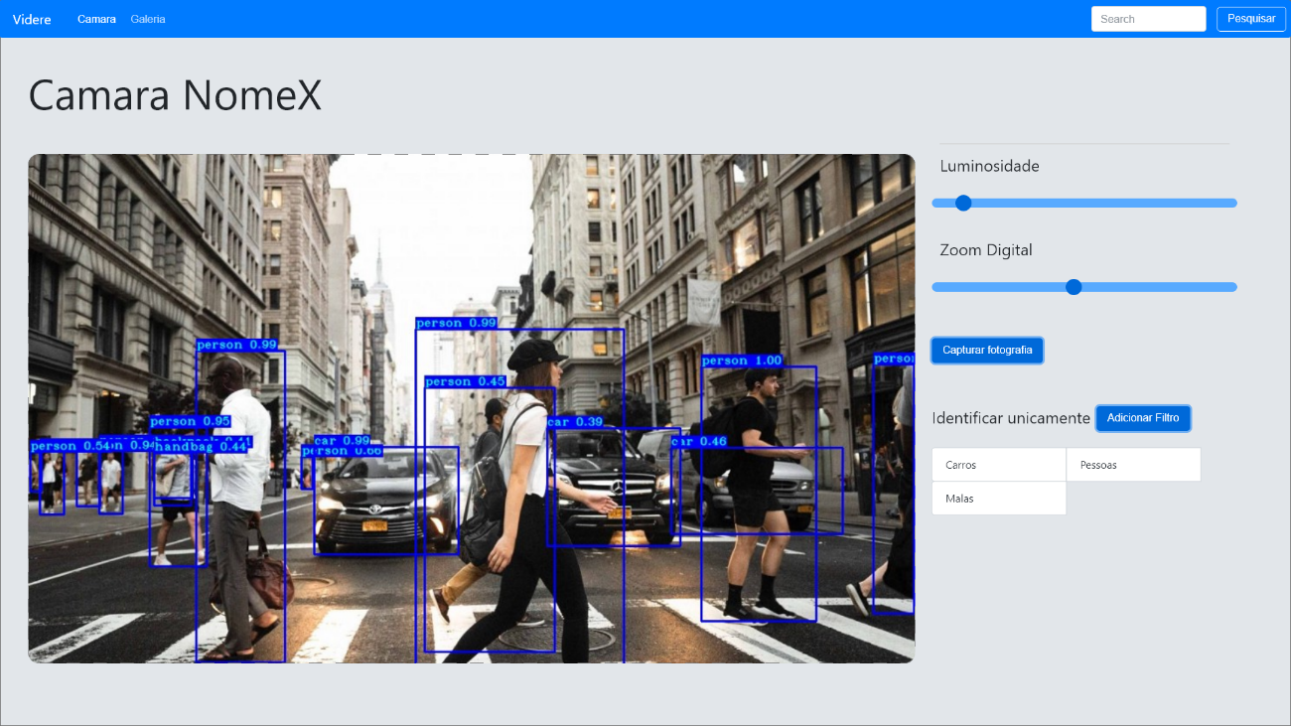

Bugs inicais quando se experimentava duas sessões ao mesmo tempo:

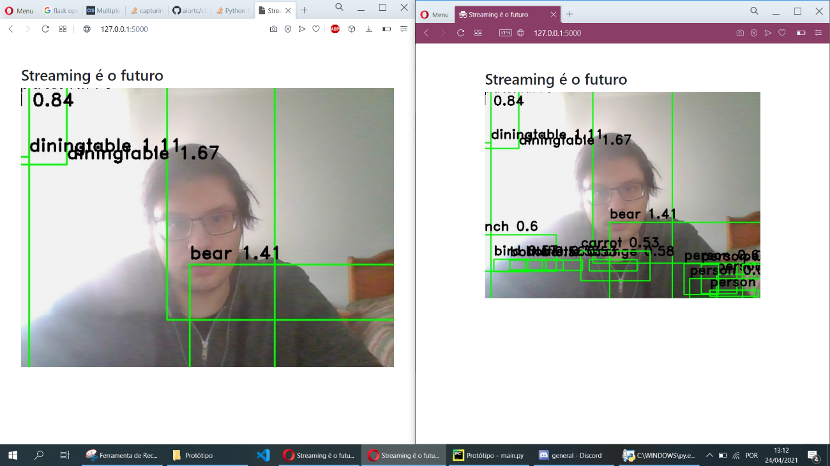

Sistema de Login:

